ECONOMIC FRUSTRATION GRIPS MANY DEVELOPING COUNTRIES
Published by: NYT, December 6, 1982, by Alan Riding
MEXICO CITY, Dec. 3— The recession in the industrialized nations has translated into increased economic hardship and new political tensions across much of Asia, Africa and Latin America.
Last year, for example, the economies of the developing world grew by an average of just six-tenths of 1 percent and, with population growth racing ahead, per capita income fell for the first time in 20 years. This year the figures are even worse.
''Zero growth in a country like Sweden is hardly a disaster,'' one United Nations development economist said, ''but in the third world it means condemnation to perpetual poverty.'' In Role of a Spectator
In addition, more than at any time since World War II, the industrial powers are obsessed by their own problems and are mostly deaf to the cries for help from the poorer nations of the Southern Hemisphere.
As a result, the third-world nations have been reduced to the role of spectator, unable to influence the main causes of - or solutions to - their problems.
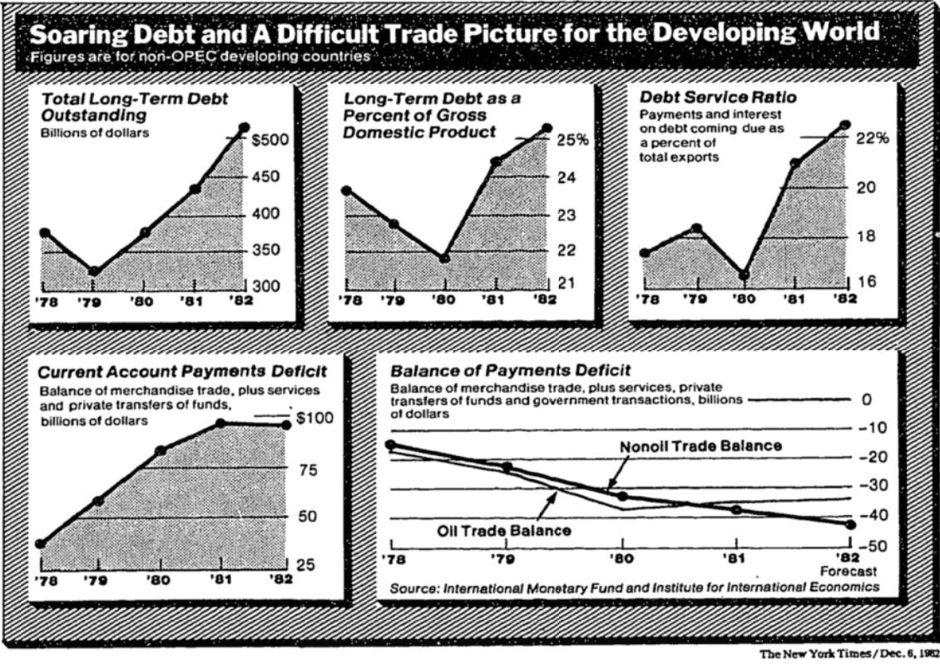
''The countries of the South have not sinned against the world economy,'' former President Jose Lopez Portillo of Mexico told the United Nations General Assembly last Oct. 1. ''Our efforts to grow, to conquer hunger, sickness, ignorance and dependence have not caused the international crisis.'' Symbol of Vulnerability
Mexico has become a symbol of the third world's vulnerability to the world recession. When the economy of the industrialized world began to stumble in the late 1970's, Mexico's boom continued, fed by rising oil exports and huge loans from the banking systems of the Western nations.
By early this year, however, the expanding world recession had weakened oil prices and raised interest rates. And Mexico, perhaps the only large developing country still growing, was sucked into its worst financial crisis ever.
The shock waves from the Mexican slump were immediately felt around the world. Not only was Mexico unable to keep up payments on its $80 billion foreign debt but its plight also raised the specter that many developing nations might default on their debts and ruin major banks throughout the West.
If an energy-rich, semi-industrialized nation such as Mexico could not resist the impact of the world economic slowdown, economists argued, what chance did dozens of smaller, poorer countries have?
The severe economic crises that have swept the third world in the last two years - fueled by low prices for commodities, high interest rates and trade restrictions dictated by the United States, Western Europe and Japan - provide the answer.
Commodity prices have in fact reached their lowest level in 30 years, with food prices falling 21.3 percent, agricultural raw materials 13 percent and minerals 12.3 percent during 1981, and most have continued to fall this year. Tied to a Single Export
In addition, the economies of many countries are tied to a single export, such as sugar in Cuba, copper in Zaire, coffee in Kenya and jute in Bangladesh. For Central America's agricultural economies, the terms of trade - the relative prices of its exports and imports - have deteriorated 40 percent since 1977.
Even the softening of world oil prices over the last 18 months has brought little relief to developing nations whose balance-of-payments problems were initially brought on by high oil prices.
They had learned to cover their deficits by borrowing abroad, but the fall in oil prices evaporated excess liquidity on financial markets - cash from the oil producers was reduced -and many governments could no longer borrow to pay their debts.
The rush of countries seeking renegotiation of their foreign debts or emergency help from the International Monetary Fund this year is evidence of their distress. Scope and Depth of Crisis
And the fact that these petitioners include newly industrialized countries such as Mexico and Brazil, less developed countries such as Honduras and Bangladesh and even socialist nations such as Poland and Cuba illustrates both the scope and depth of the crisis.
Yet while the economic destiny of the third world will unavoidably be determined by events far beyond their borders, many experts believe that these countries will also shape the fate of the industrial powers.
''In contrast to the Depression of the 1930's,'' a United Nations economist said, ''today there is genuine worldwide economic interdependence.''
Third-world debt problems, threatening the stability of the entire international monetary system, have already prompted Washington to provide emergency credit to ''bail out'' first Mexico and now Brazil, which recently received a $1.2 billion bridge loan from the United States during President Reagan's visit there. Imports Are Discouraged
But insufficient financing and low export earnings are also forcing developing countries to close their markets to imports from industrialized nations.
''The recessions are feeding on each other,'' the United Nations economist said. ''The collapse of the third world will hurt the first world's recovery.''
This is apparent in the relationship between Mexico and the United States. The impact of the American recession has been felt by Mexico indirectly, through lower export prices for oil and other raw materials and higher interest rates, and also directly, through a decline in tourism and tighter trade protectionism.
In turn, Mexico's slump has seriously damaged commerce and real estate markets across the American Southwest, while the flow of migrants entering the United States illegally has increased in recent months as unemployed Mexicans seek work. A Major Trading Partner
Since 1980 Mexico has also become the third-largest trading partner of the United States, due both to oil imports from Mexico - Mexico is now the United States' principal foreign supplier of oil - and to American industrial exports, although the level of those exports is now declining.
Further, at least $30 billion of Mexico's $80 billion foreign debt is owed to American commercial banks, with the Bank of America and Citicorp each owed about $3 billion.
The reality of the interdependence between the developing world and the industrial West, however, has not been recognized by Washington and other Western capitals, in the view of third-world nations.
Not only has the aid flow to poor countries fallen steadily in recent years but also third-world efforts to promote a so-called new international economic order have repeatedly been blocked. Searching for Recovery
In many United Nations forums and at the 22-nation North-South summit conference held in Cancun, Mexico, last year, Britain, West Germany and Japan have endorsed the Reagan Administration's view that the answer to the problems of developing countries lies in the recovery of the developed economies. ''Stay the course'' has therefore become the message to the third world as well as to the American people.
There are United Nations development experts who point out, however, that the experience of the last 25 years shows that many developing nations have a greater potential for growth than the industrial economies.
Between 1955 and 1980, for example, while developed countries grew by an annual average of 4.1 percent, the third world's economies expanded by 5.4 percent. These experts, therefore, believe that the United States and other Western powers, by helping to sustain economic activity in the third world, would also be alleviating their own recessions. Quick Progress Sought
Nowhere is economic opportunity more evident in the third world than among the oil-exporting nations, which are looking to advance their economies quickly through huge imports and investments.
Some, such as Mexico, Venezuela and Nigeria, are experiencing slumps. But several others, including Saudi Arabia and Kuwait, are still growing, albeit more slowly than in 1979 and 1980. PICK UP FIRST AND LAST ADD
A few small countries that are not oil producers, such as Singapore, Taiwan, South Korea and Hong Kong -all, significantly, within Japan's sphere of influence - have also undergone dramatic economic transformations over the last two decades.
Meanwhile many medium-sized countries, including Mexico, Brazil, Nigeria and Indonesia, have built impressive industrial foundations. Even China and India, burdened by huge populations, have recorded marked progress. Widening Gap Is Observed
Although the difference between some industrialized and middlelevel countries has been reduced, the gap between the richest and poorest nations has widened. And, particularly in Africa, countries unable to attract foreign capital or credit and dependent on shrinking aid from abroad have lacked fuel for development.
Moreover, many rural societies are no longer able to feed themselves. In Africa, for example, there is less food per capita today than there was 20 years ago, with sub-Saharan Africa frequently ravaged by starvation.
Despite such distinctions, however, the current crisis has been felt throughout the third world, albeit in different ways. Africa is most hurt by the lack of foreign aid and low prices for its commodity exports. Latin America's big borrowers have been squeezed by high interest rates and the shortage of foreign credit. And Asia, though so far least affected by the recession, is fast losing markets for its manufactured exports. Trouble for Oil Importers
In addition, the sharp increase in oil prices in 1979 pointed to serious trouble for developing nations that are not oil producers. Brazil, the Philippines and other energy importers immediately cut back on imports and reduced government spending to protect their balance of payments.
Nevertheless, the total current-account payments deficit for all third world countries surged to $115 billion in 1981. For a while, however, the surplus revenue of Arab oil exporters, efficiently recycled through Western financial markets, provided a credit cushion for countries with payments difficulties. And even such large oil exporters as Mexico, Venezuela, Algeria and Indonesia tapped these resources to maintain high growth rates.
More than ever, Western banks also turned their attention to the third world, competing fiercely in a borrowers' market to dispose of their excess liquidity, frequently at low interest rates with small profit margins. Worldwide Squeeze Felt
Last year foreign banks poured more than $19 billion of new money into Mexico alone, while the third world's total foreign debt rose to $517 billion.
By mid-1981, however, the Reagan Administration's tight money policies were squeezing the entire world economy. High interest rates and a falling rate of inflation in the United States dramatically strengthened the dollar. This helped to slow investment, consumption and growth in industrialized countries because a strong dollar attracts capital from other countries.
This slowdown, in turn, softened oil prices and further weakened demand for other raw materials. Within months, even the dollar surplus from the Arab oil countries had dropped sharply.
As a result, acute financial crises have erupted like brush fires across the developing world this year, forcing a number of governments to devalue currencies, cut imports and renegotiate their foreign debts. Dimensions of a Crisis
Yet it was only recently, when the larger countries of Latin America began lining up outside the International Monetary Fund, that their individual problems took on the dimensions of a global monetary crisis. For example, Mexico, Brazil and Argentina owe a total of $200 billion abroad, which they cannot repay.
The immediate fear among bankers in New York and London was that these countries might organize a ''debtors' cartel'' and unilaterally declare a moratorium on all their debt servicing.
Such a move would decimate the West's financial system, so bankers have tried to show flexibility, ignoring defaults on interest payments and even providing new credits in exchange for austerity programs worked out with the I.M.F.
''We helped them get into this pickle,'' one foreign banker said, referring to Mexico's problems, ''and we've got no choice but to help them get out if we ever want to be repaid.'' Renegotiation Indicated
Even so, Mexico has already indicated that, unable to liquidate any of the $20.5 billion in short- and long-term obligations maturing before the end of 1983, it will have to renegotiate its entire debt. To cover interest and indispensable imports, the country must also borrow another $5 billion abroad next year.
However, just as every 1 percent rise in interest rates costs Mexico an additional $500 million, the recent drop in the prime rate in the United States should bring some relief.
Once the mechanics of debt rescheduling are worked out by Mexico and other affected nations, though, the real weight of the economic crisis will begin to be felt, many analysts believe.
Last year, for example, Mexico's gross domestic product grew by 8 percent and this year by 1 percent, but next year the country is expected to register its first negative economic growth in 50 years. Outlook for Inflation
Typically this stagnation will be accompanied by inflation, the analysts suggest.
While unemployment rises and production falls, Mexico must cut its huge budget deficit by raising gasoline, electricity and food prices as well as taxes, all of which will mean a sharp reduction in real wages. And this pattern is likely to be repeated in Brazil and Argentina.
In many smaller countries, slumps are already well under way. Nations in Central America are expected to face a third successive year of zero growth or negative growth in 1983, creating new unemployment and hardship in a region already convulsed by political violence.
In many African countries, the number of people living at a subsistence level has grown rapidly, and Tanzania is still as poor today as it was when it achieved independence in 1961. Even in Singapore, growth rates have been halved and seem likely to shrink further. Less Vulnerable Nations
The world's most populous nations, China and India, have so far escaped serious recessions because their economies are more self-sufficient than most others and therefore less vulnerable to events in the industrialized world.
India, in particular, has dramatically improved its agricultural performance during the last decade, and its economy grew 5 percent last year. But its heavy bill for oil imports also forced it to turn to the International Monetary Fund for a record $5.6 billion credit in late 1981.
But while the third world's economic outlook is predictably grim, the political consequences of the recession are less foreseeable. Even in the poorest countries, the standard of living has generally improved since World War II. But now, analysts say, it appears certain to worsen. Wide Income Disparities
In larger countries, where income disparities are often enormous, the frustrations of the poor will be compounded by the disappointed expectations of the middle classes. And rarely are the burdens of economic crises shared equally by different classes in developing nations, a situation that also creates social tensions.
Adding to the difficulties, analysts say, is that over the last 30 years no nation has emerged as a viable model of development, offering blueprints for both social progress and economic growth.
As a result, unless the current recession spawns dramatic international economic changes, developing countries will face the same dilemmas once the crisis is over.
The most intense debate has centered on choosing between agricultural or industrial development, but neither has proved satisfactory. Investment in agriculture has insured food self-sufficiency but has exposed economies to the vagaries of world commodity prices, while industrial expansion has saved foreign exchange by replacing imports but has failed to satisfy job demands in urban areas. Complications Encountered
Throughout the third world, in fact, there are monuments to the complex dynamics of development.
Even in times of plenty many inhabitants of countries like Mexico, Nigeria and Indonesia, with great natural resources and broad industrial bases, were left without jobs or adequate food. Meanwhile, economic growth in a vast swath of poorer nations cannot keep up with expanding populations.
But if the 1960's and 1970's offered developing countries at least the prospect of economic growth, analysts say that the next few years are likely to involve a struggle for survival, unmitigated by illusions that the aid flow will increase or that commodity prices will altruistically be raised.
Instead, they say, the developing countries can only hope that recovery of the economies of the industrialized West will eventually revive demand for their products and free resources that can be channeled to them. Their future, however, is out of their hands.

